**Abhiram Basa**

**Assessment 3 of Data Engineering - 06/12/23**

Today we executed some Tcl commands, joins like inner, left outer join, right outer join and full outer join, constraints, normalization(keys).

**Having and GROUP BY clause**

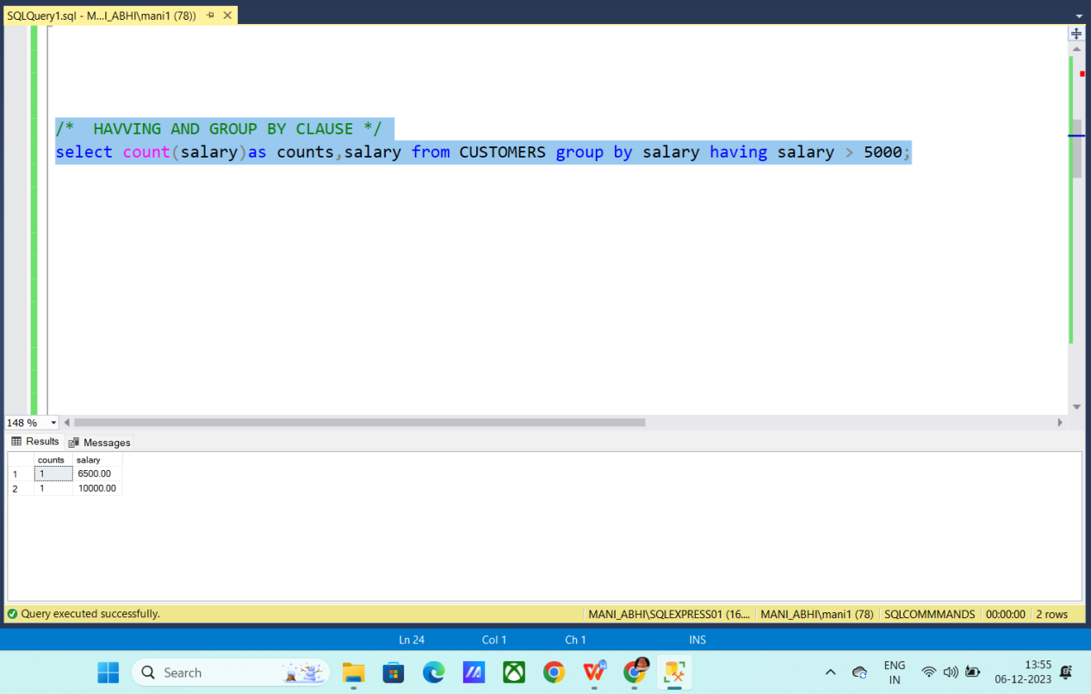

**Commit, roll back, save point**

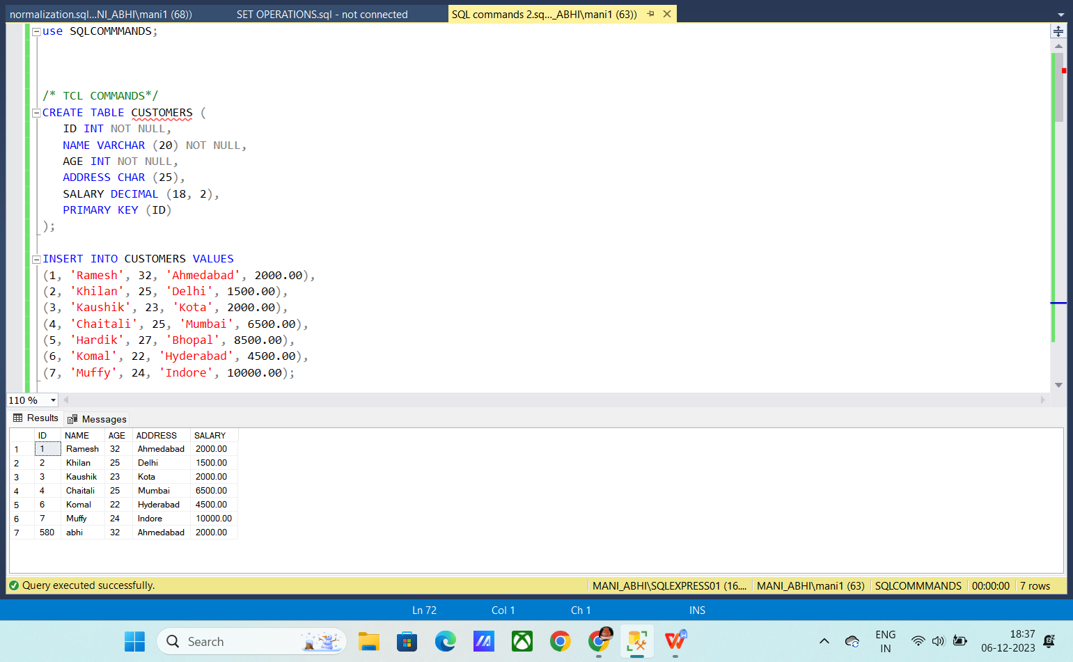

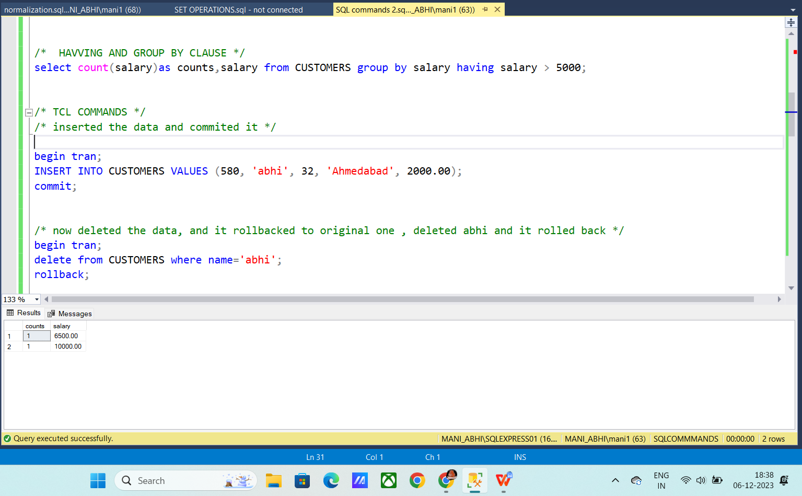

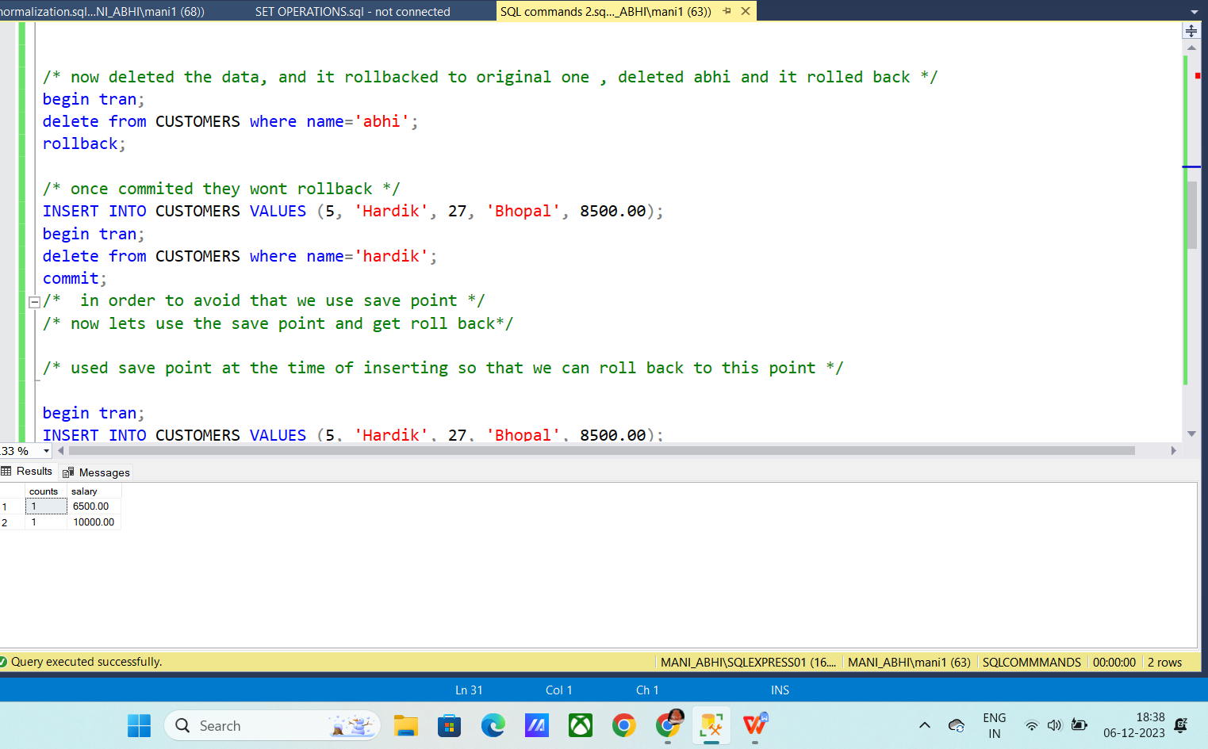

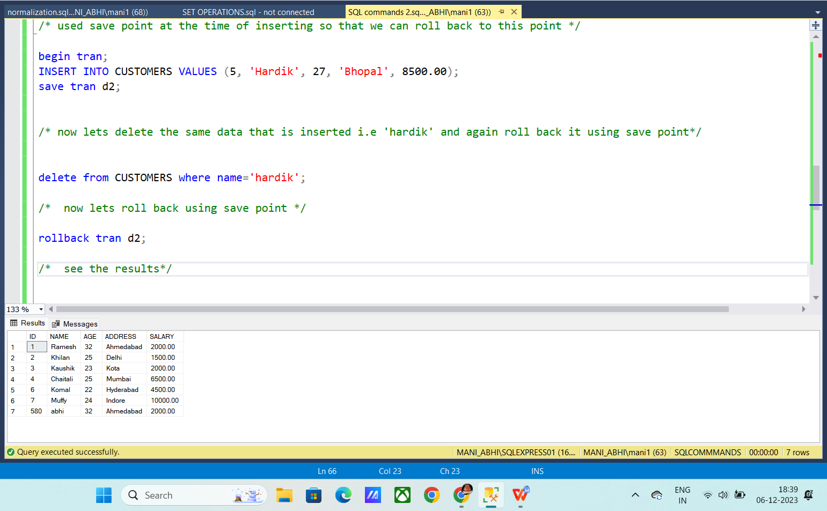

**Set operations :**

**Union operation**

**it results all the data from both the tables and avoid duplicates**

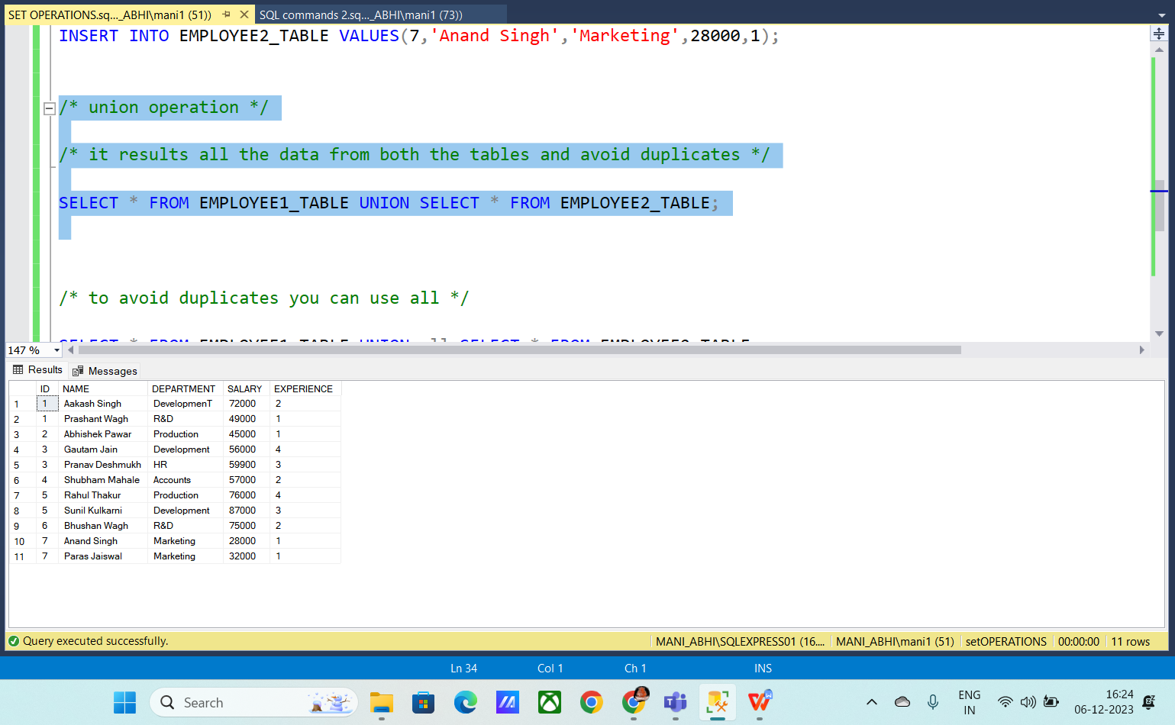

**to avoid duplicates you can use all**

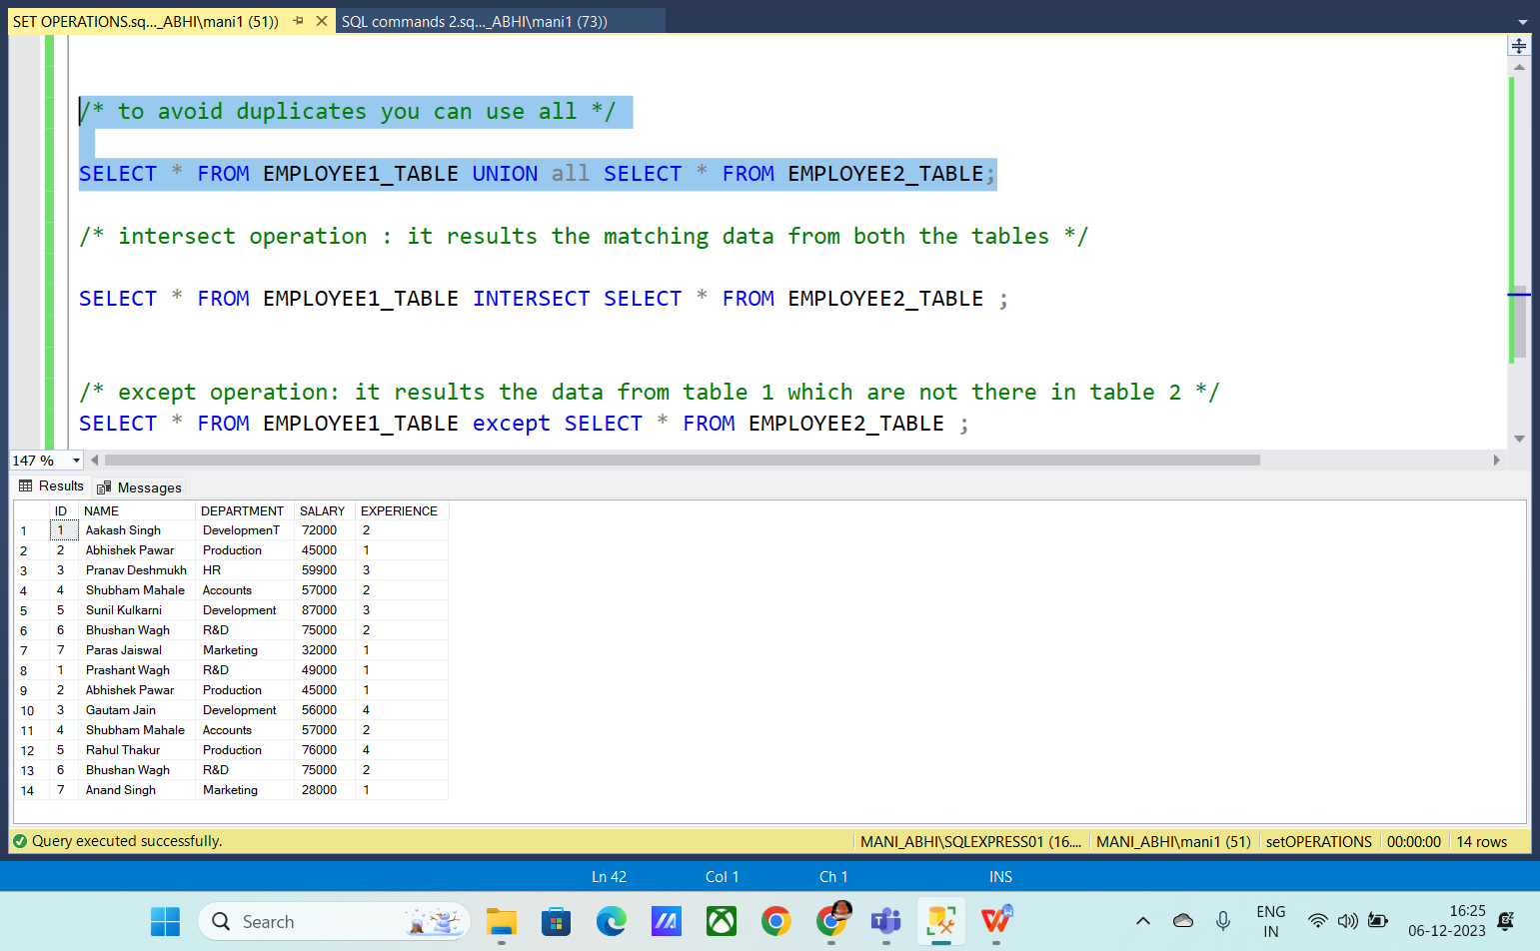

**intersect operation : it results the matching data from both the tables**

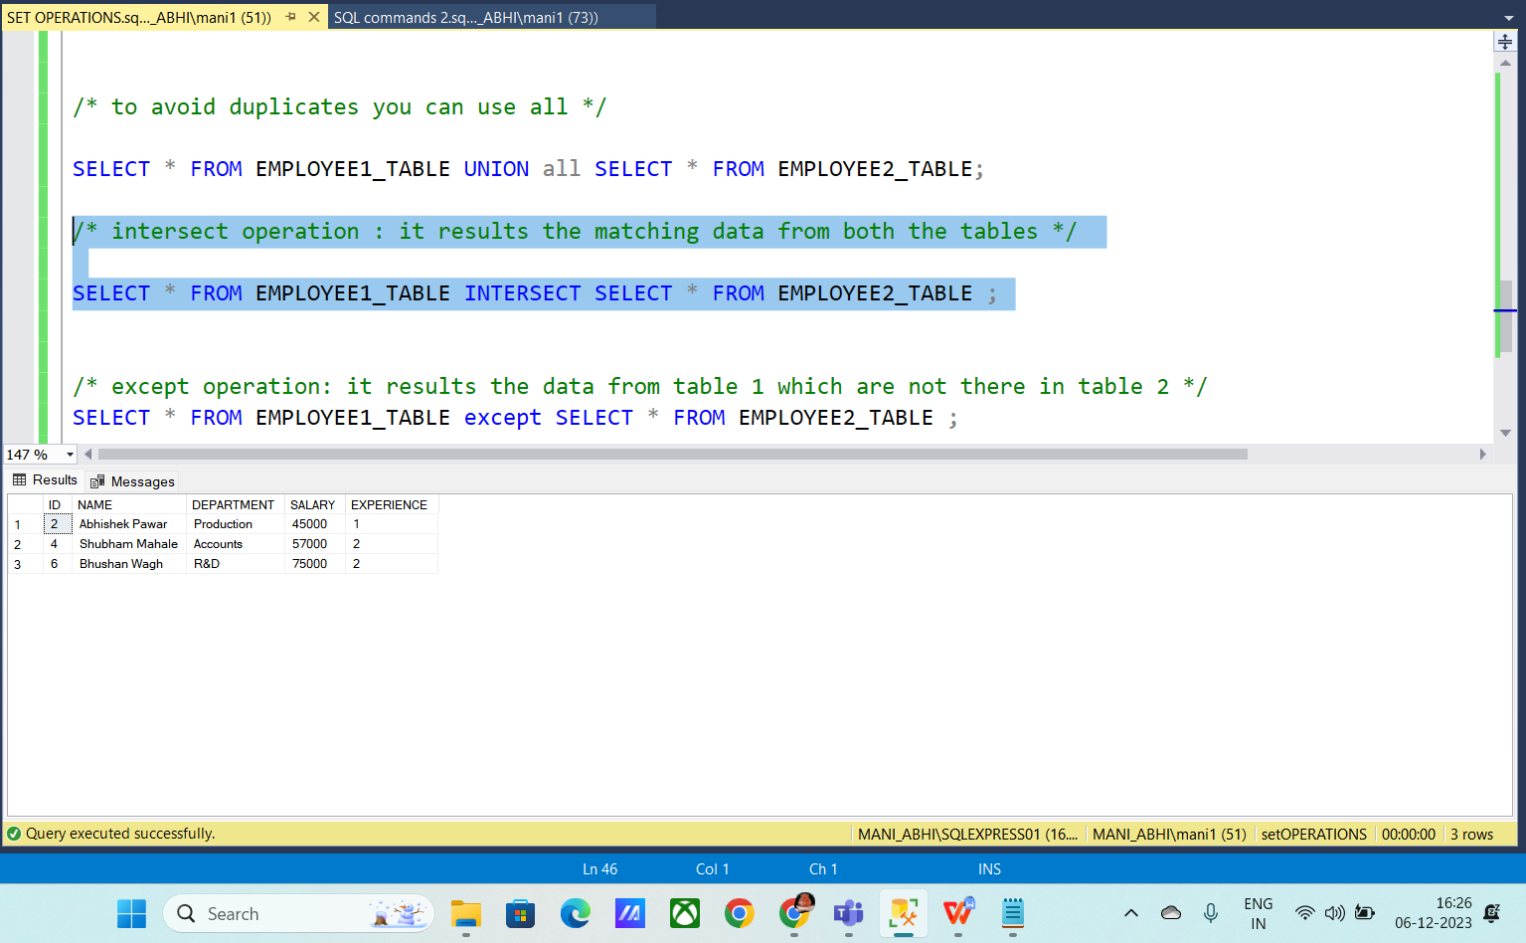

**except operation: it results the data from table 1 which are not there in table 2**

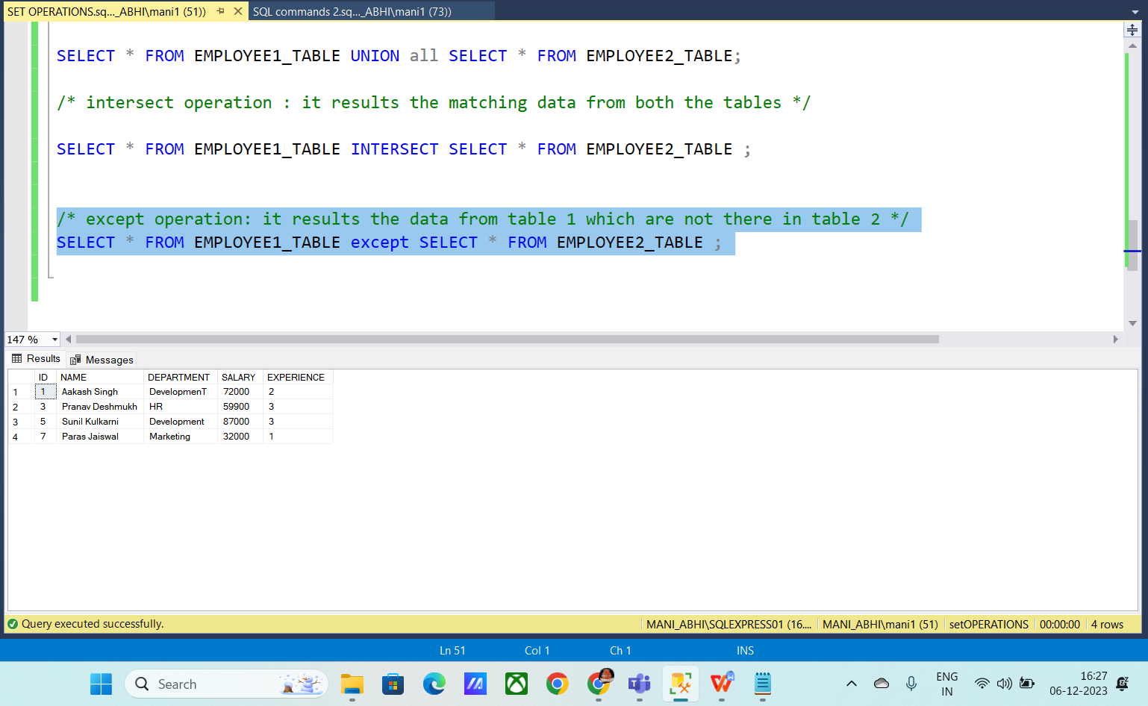

**Constraints:**

**Unique**

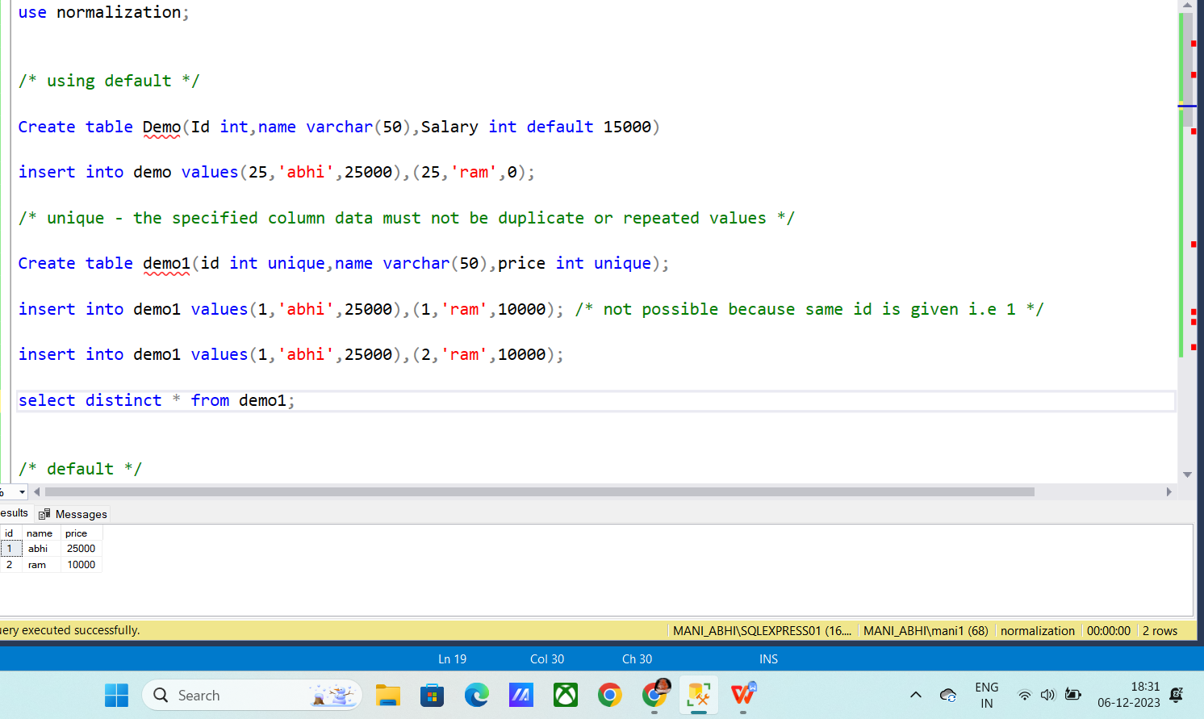

**Default**

I have given default value as 5000 so it took it as default value when you give nothing.

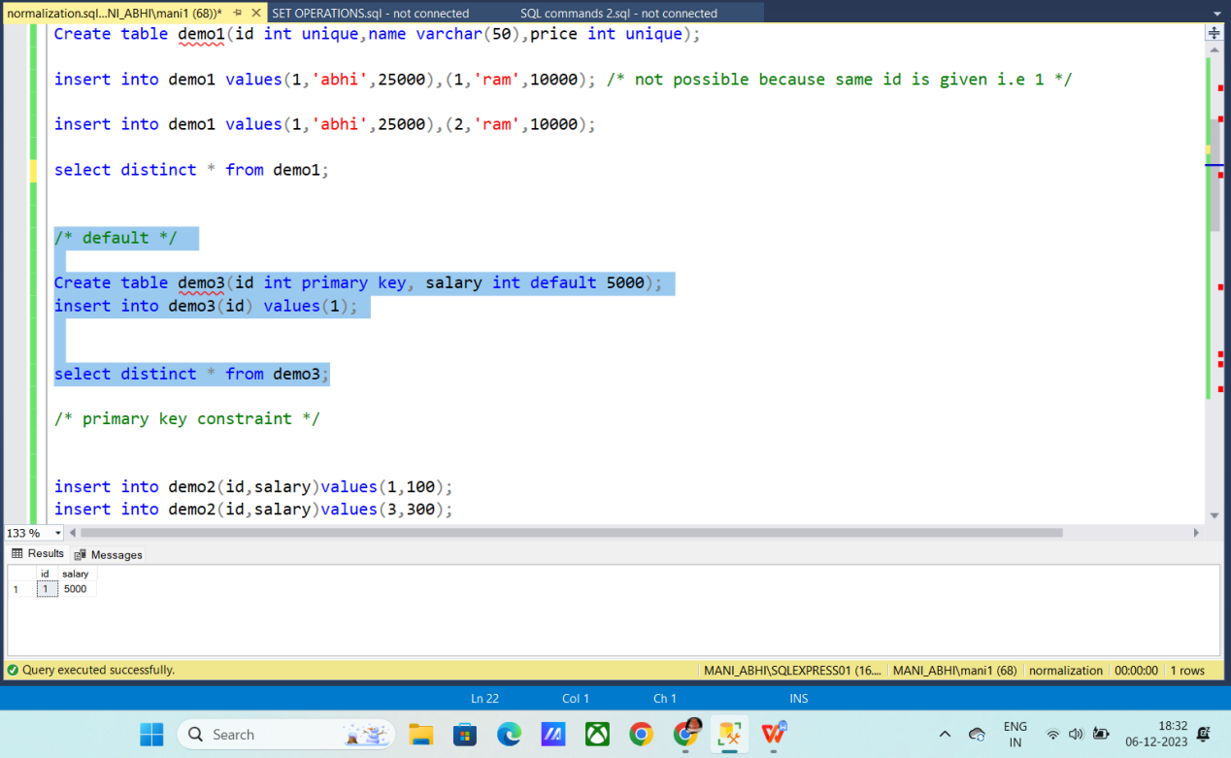

**Normalization :**

**Primary key:**

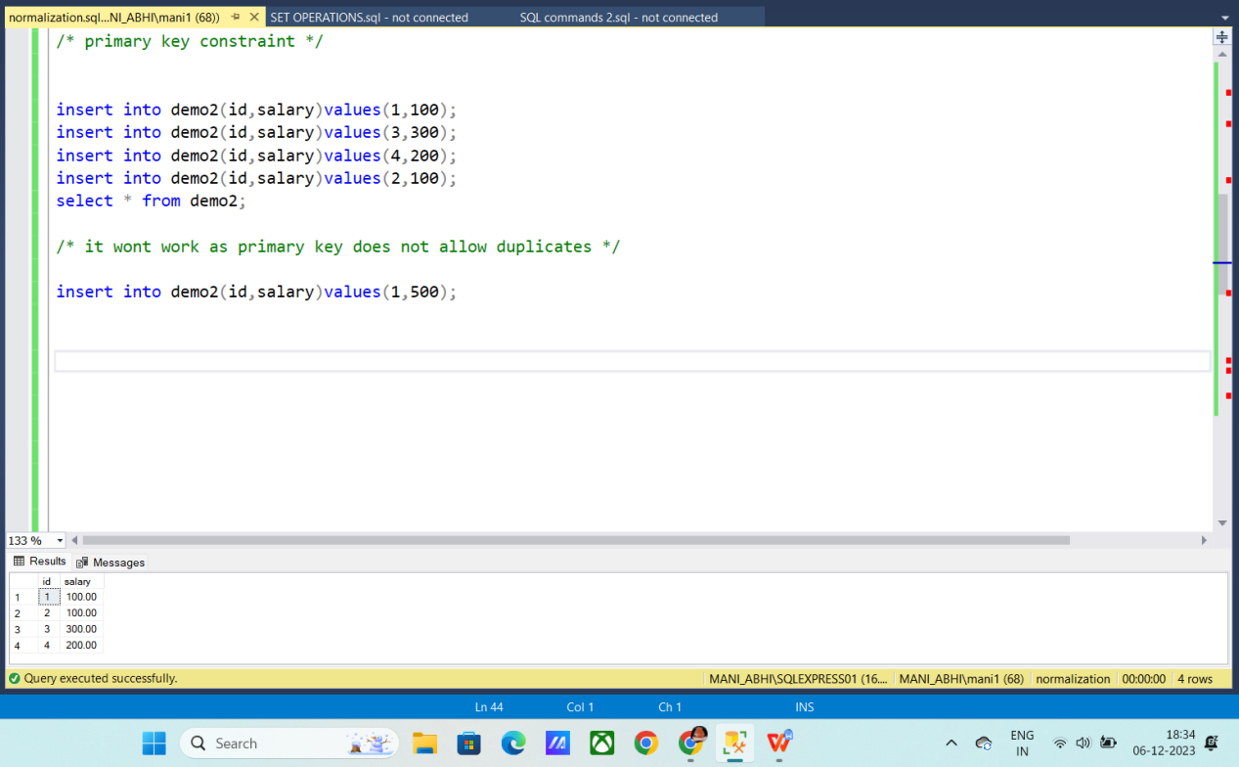

**Composite and foreign keys:**

